**5.1 PRACTICE**

M.Mahathi

192324098

1.Using a ternary operator, write an if/else statement that will return true or false if the variable x is less than or equal to 7.

Code:

boolean result = (x <= 7) ? true : false;

2. Write a program that prompts the user to enter two floating point (double) numbers and an operator ( *, +, /, %, -). Print the results of the given operation. For reading the command line, use the Scanner class. Write the program first using switch logic, then re-write the program using if/else logic

Code:

import java.util.Scanner;

public class CalculatorSwitch {

public static void main(String[] args) {

Scanner scanner = new Scanner(System.in);

System.out.print("Enter first number: ");

double num1 = scanner.nextDouble();

System.out.print("Enter second number: ");

double num2 = scanner.nextDouble();

System.out.print("Enter operator (+, -, *, /, %): ");

char operator = scanner.next().charAt(0);

double result;

switch (operator) {

case '+':

result = num1 + num2;

break;

case '-':

result = num1 - num2;

break;

case '*':

result = num1 * num2;

break;

case '/':

result = num1 / num2;

break;

case '%':

result = num1 % num2;

break;

default:

System.out.println("Invalid operator");

return;

}

System.out.println("The result is: " + result);

}

}

3.True or False: IF/ELSE statements can always be replaced with SWITCH statements.

Code:

import java.util.Scanner;

public class CalculatorIfElse {

public static void main(String[] args) {

Scanner scanner = new Scanner(System.in);

System.out.print("Enter first number: ");

double num1 = scanner.nextDouble();

System.out.print("Enter second number: ");

double num2 = scanner.nextDouble();

System.out.print("Enter operator (+, -, *, /, %): ");

char operator = scanner.next().charAt(0);

double result;

if (operator == '+') {

result = num1 + num2;

} else if (operator == '-') {

result = num1 - num2;

} else if (operator == '*') {

result = num1 * num2;

} else if (operator == '/') {

result = num1 / num2;

} else if (operator == '%') {

result = num1 % num2;

} else {

System.out.println("Invalid operator");

return;

}

System.out.println("The result is: " + result);

}

}

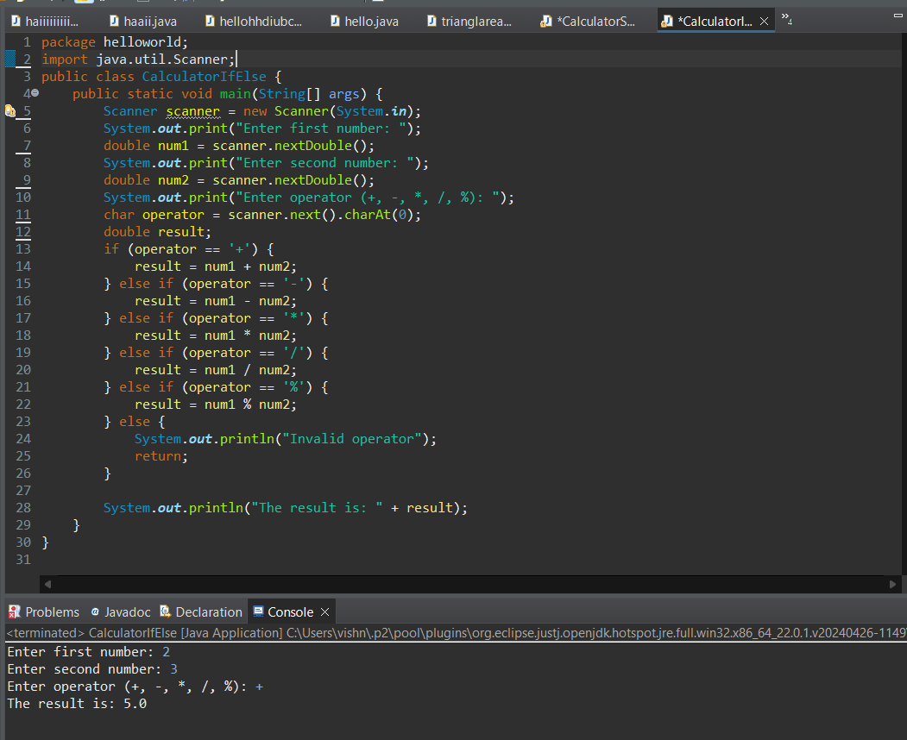

4.Write a Java program to do the following that determines your weight on another planet. The program should ask for the user's weight on Earth, then present a menu of the other planets in our solar system. The user should choose one of the planets from the menu. The program should display the phrase like the following: “Your weight on Mars is 55 lbs.” Use

Code:

import java.util.Scanner;

public class WeightOnPlanets {

public static void main(String[] args) {

Scanner scanner = new Scanner(System.in)

System.out.print("Enter your weight on Earth: ");

double earthWeight = scanner.nextDouble();

System.out.println("Choose a planet:");

System.out.println("1. Mercury");

System.out.println("2. Venus");

System.out.println("3. Mars");

System.out.println("4. Jupiter");

System.out.println("5. Saturn");

System.out.println("6. Uranus");

System.out.println("7. Neptune");

int choice = scanner.nextInt();

double conversionFactor = 0.0;

switch (choice) {

case 1: conversionFactor = 0.38; break;

case 2: conversionFactor = 0.91; break;

case 3: conversionFactor = 0.38; break;

case 4: conversionFactor = 2.36; break;

case 5: conversionFactor = 0.92; break;

case 6: conversionFactor = 0.89; break;

case 7: conversionFactor = 1.13; break;

default: System.out.println("Invalid choice"); return;

}

double planetWeight = earthWeight * conversionFactor;

String planetName = "";

switch (choice) {

case 1: planetName = "Mercury"; break;

case 2: planetName = "Venus"; break;

case 3: planetName = "Mars"; break;

case 4: planetName = "Jupiter"; break;

case 5: planetName = "Saturn"; break;

case 6: planetName = "Uranus"; break;

case 7: planetName = "Neptune"; break;

}

System.out.printf("Your weight on %s is %.2f lbs.%n", planetName, planetWeight);

}

}

5.Write a Java program that will decide if a student gets into Mountville University. Students must have one of the following criteria:

• been a valedictorian or salutatorian of a school of 1400 or more

• had a gpa of 4.0 or better and a SAT score of 1100 or more

• had a gpa of 3.5 or better and an SAT score of 1300 or more

• had a gpa of 3.0 or better and an SAT score of 1500 or more

Code:

import java.util.Scanner;

public class MountvilleAdmission {

public static void main(String[] args) {

Scanner scanner = new Scanner(System.in);

System.out.print("Enter your GPA: ");

double gpa = scanner.nextDouble();

System.out.print("Enter your SAT score: ");

int sat = scanner.nextInt();

System.out.print("Are you a valedictorian or salutatorian of a school with 1400 or more students? (yes/no): ");

String vOrS = scanner.next();

boolean admitted = false;

if (vOrS.equalsIgnoreCase("yes")) {

admitted = true;

} else if (gpa >= 4.0 && sat >= 1100) {

admitted = true;

} else if (gpa >= 3.5 && sat >= 1300) {

admitted = true;

} else if (gpa >= 3.0 && sat >= 1500) {

admitted = true;

}

if (admitted) {

System.out.println("Congratulations! You are admitted to Mountville University.");

} else {

System.out.println("Sorry, you are not admitted to Mountville University.");

}

}

}

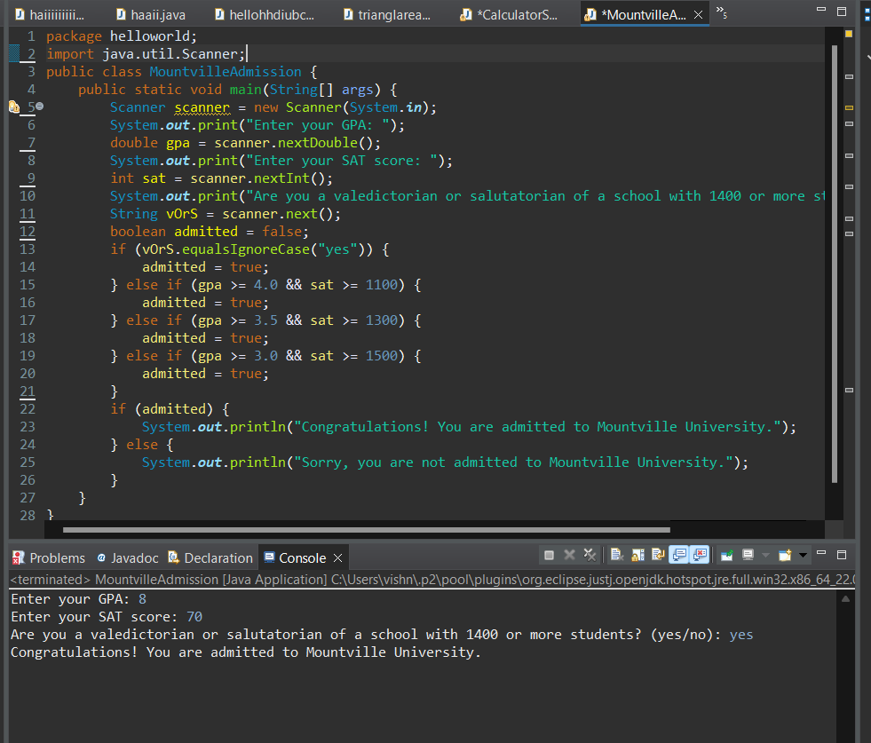

6.A professor in college will allow a student to be excused from the final exam if either of the following is true: • They have a 90% average or higher in the class and have missed 3 or less class lectures. • They have a 80% average or higher in the class and have not missed any class lectures. • The program below will determine whether a student can get out of the exam or not. • Rewrite the program so only one if statement is used.

Code:

import java.util.Scanner;

public class FinalExam {

public static void main(String[] args) {

double average;

int daysAbsent;

boolean exempt = false;

Scanner reader = new Scanner(System.in);

System.out.println("This program will determine if you can get out of the final exam.");

System.out.println("Please answer the following questions.");

System.out.print("What is your average in the class? ");

average = reader.nextDouble();

System.out.print("How many class lectures have you missed? ");

daysAbsent = reader.nextInt();

if ((average >= 90 && daysAbsent <= 3) || (average >= 80 && daysAbsent == 0)) {

exempt = true;

}

if (exempt) {

System.out.println("Congratulations! You are exempt from the final exam.");

} else {

System.out.println("You are not exempt from the final exam.");

}

}

}

7.Write a program that calculates the number of buckets of paint to use for a room and the optimal number of cans to purchase. You need to ask the height of the room and the length and width of the room. The room is rectangular. You must paint the walls and the ceiling but not the floor. There are no windows or skylights. You can purchase the following size buckets of paint.

• 5-liter bucket costs $15 each and covers 1500 square feet.

• 1-liter bucket costs $4 and covers 300 square feet.

import java.util.Scanner

public class PaintCalculator {

public static void main(String[] args) {

Scanner scanner = new Scanner(System.in);

System.out.print("Enter the height of the room (in feet): ");

double height = scanner.nextDouble();

System.out.print("Enter the length of the room (in feet): ");

double length = scanner.nextDouble();

System.out.print("Enter the width of the room (in feet): ");

double width = scanner.nextDouble();

double wallArea = 2 * height * (length + width);

double ceilingArea = length * width;

double totalArea = wallArea + ceilingArea;

double litersNeeded = totalArea / 300;

int fiveLiterBuckets = (int) (litersNeeded / 5);

int oneLiterBuckets = (int) Math.ceil(litersNeeded - (fiveLiterBuckets * 5));

System.out.println("You need " + (fiveLiterBuckets + oneLiterBuckets) + " liters of paint.");

System.out.println("Purchase " + fiveLiterBuckets + " five-liter buckets and " + oneLiterBuckets + " one-liter buckets.");

}

}

